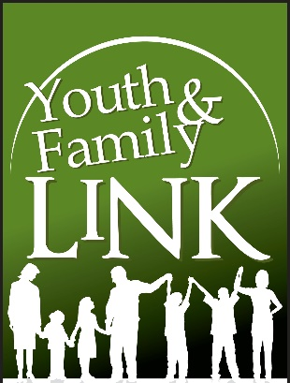
Mothering Together Virtual Peer Support Group Registration
This support group offers Moms the opportunity to share, understand, praise, support, reflect, teach, and interact parent-to-parent. This group may be really good for you if you are overwhelmed, and struggling. This group is also advice, and judgement free zone!
*MUST have at least 1 child under the age of 2, OR MUST be pregnant to participate.
*For single, experienced, new, and pregnant Moms.
*10 week sessions

Name :____________________________________________

Phone # :__________________________________________

Alternate Phone # :___

Address :

E-mail :____________________________________________

Do you Identify as a refugee or immigrant to the United States?
Yes
No

Do you Identify as Physically, Emotionally, or Cognitively Disabled? (Circle all that apply) :
Emotionally
Physically
Cognitively

Are you currently pregnant? (Please Circle below) :
Yes
No

*IF currently pregnant :
Due Date :___________________________________
Gender :_____________________________________

Are you new to this group? (Please circle below) :
Yes
No

How did you hear about this group?

Race / Ethnicity :__________________________________

Additional Information you would like us to know :

Child 1 NAME :___________________________________________________
Gender :___________________________________________________
Date of Birth :_______________________________________________

Child 2 NAME :___________________________________________________
Gender :___________________________________________________
Date of Birth :_______________________________________________

Child 3 NAME :___________________________________________________
Gender :___________________________________________________
Date of Birth:_______________________________________________

Child 4 NAME :___________________________________________________
Gender :___________________________________________________
Date of Birth :_______________________________________________

Please select which time slot you prefer (circle) :
10 – 11am
6 – 7pm

Additional Comments :

