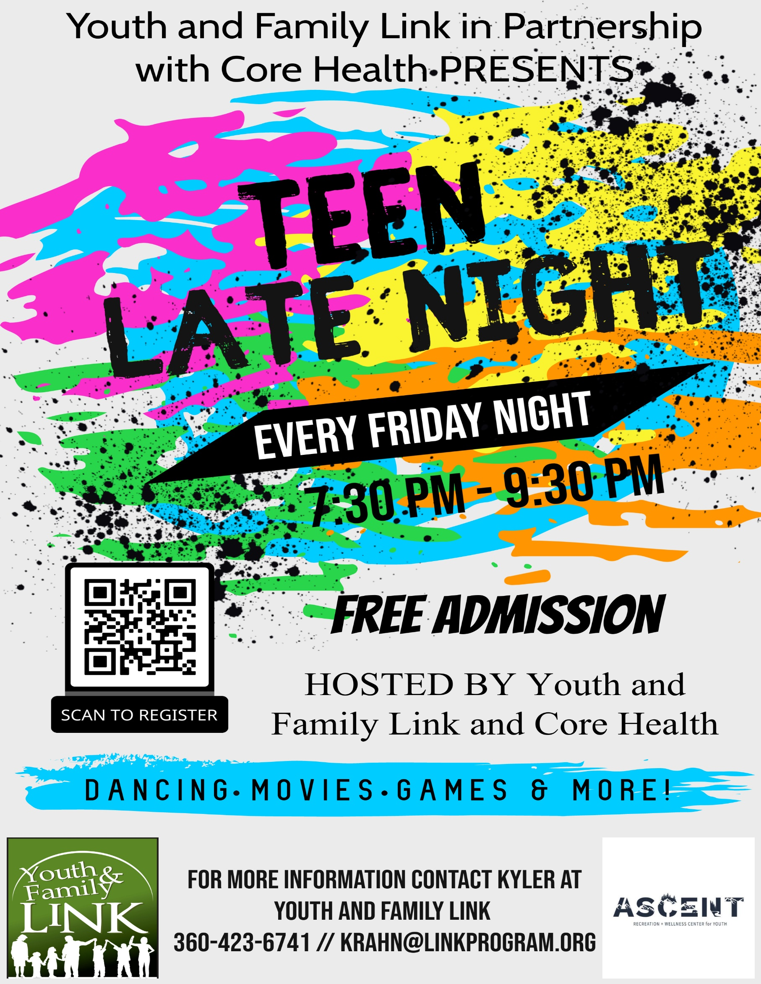
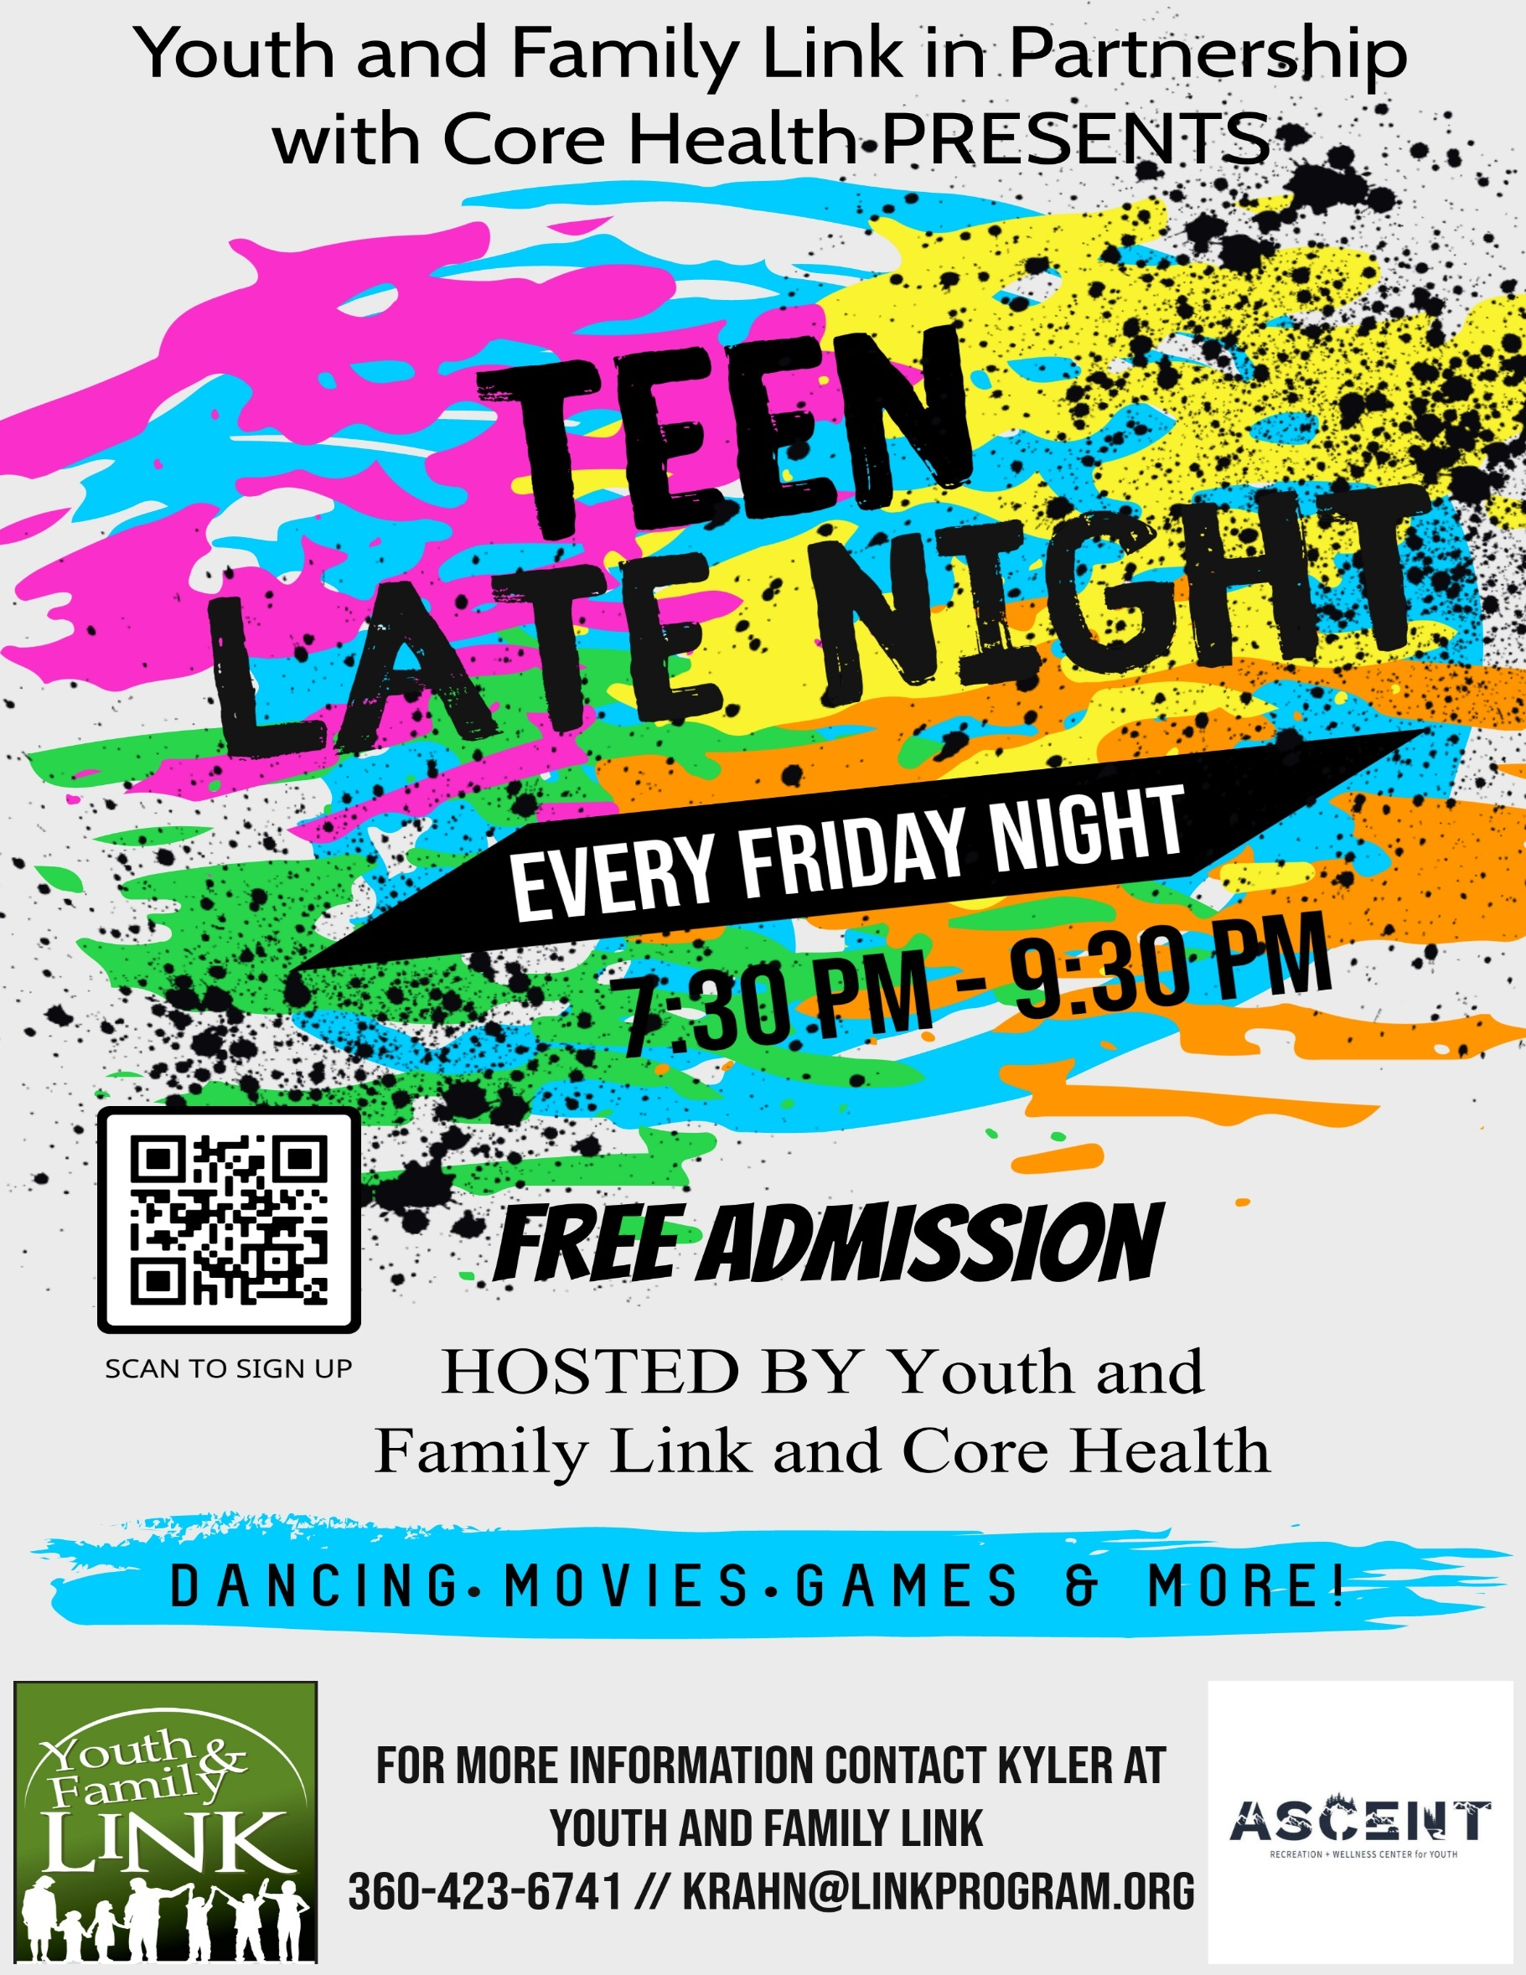

DAYS | LOCATION
3/10/23 | CORE Health Ascent Youth Activity Center
3/17/23 | Youth and Family Link
3/24/23 | Youth and Family Link
3/31/23 | CANCELLED
4/7/23 | CORE Health Ascent Youth Activity Center
4/14/23 | Youth and Family Link
4/21/23 | Youth and Family Link
4/28/23 | CANCELLED
5/5/23 | CORE Health Ascent Youth Activity Center
5/12/23 | CANCELLED
5/19/23 | Youth and Family Link
5/26/23 | Youth and Family Link
6/2/23 | CORE Health Ascent Youth Activity Center
6/9/23 | Youth and Family Link
6/16/23 | Youth and Family Link
6/23/23 | Youth and Family Link
6/30/23 | CORE Health Ascent Youth Activity Center

Youth and Family Link Address: 907 Douglas St, Longview, WA 98632
CORE Health Ascent Youth Activity Center Address: 1400 Commerce Ave, Longview, WA 98632

Received Date: Time:

Teen Late Night Registration (Complete all portions of this form, using black ink)

Teen’s Name: _________________________________________ Grade__________________________

Teen’s Preferred Name: _________________________________

Gender _____ DOB:_______________ Race/Ethnicity_____________ School _______________

Address: _________________________________________________ City: _________________________

Parent/Guardian Name: ________________________________relationship to student _________________

Home Phone: _________________ Work: ________________________ Cell: ______________________

Email: ________________________________________________________________________________

My Student receives free or reduced lunch during the school year Yes_______ No_______
My student is in the ESL program Yes_____ No_____ My Student’s Primary Language _______________
My Student is on an IEP Yes ____ No ______

Emergency Contact Information: (Who to contact if parent/guardian cannot be reached)

Name: ______________________Relationship to student: ______________ permission to pick up child Y N

Home Phone: _________________ Work: ________________________ Cell: ______________________

Name: ______________________Relationship to student: ______________ permission to pick up child Y N

Home Phone: _________________ Work: ________________________ Cell: ______________________

Medical Information

Child’s Name: _____________________________ Parent’s Name: ________________________________

Child’s Doctor Name: ______________________________ Phone: ________________________________

Hospital Preference:_______________________________________________________________________

My child has allergies or a medical condition: ⁭ Yes No If yes, please list: _________________________________________________________________
Current Medications_____________________________________________________
My child carries an EpiPen: Yes No

Any protocol for current medical conditions:

(be advised, there cannot be any medication at program (not in backpacks) including inhalers,
and staff cannot administer any medication to student)
____________________________________________________________________________________________________________________________________________________________________________________

Photo and Video Release:
Our program wants to share photos and videos of your child participating in activities at program. We ask your permission to use photos and videos taken of your child for Youth and Family Link and CORE Health promotional and educational purposes. Examples of how these photos and videos could be used are for published reports and presentations to other out of school time care providers, as well as educators, donors, public officials, Facebook, school districts, and newspapers.
Yes, Youth and family link may use pictures and video footage of my child for its promotional and educational purposes. I understand that these pictures and videos footage will become the property of Youth and Family Link and CORE Health.

___________________________________
Parent/guardian Signature

Parent Agreement: (please initial each statement)

- I understand that my youth will need picked up from the program at 9:30 sharp, unless discussed with staff prior to pick up Init _______
- I understand that the Teen Late Night program is voluntary. Youth and Family Link and CORE ASCENT Youth Center staff will supervise students. Students are expected to abide by school and program rules. If a student is unable to follow rules, he/she may be asked to leave. Youth and Family Link and CORE Health will strive to communicate with the school and home for the best interest of the child. Init __________
- I give consent for Youth & Family Link and CORE ASCENT Youth Center to exchange attendance, grades, disciplinary information, and student ID numbers, free and reduced lunch information, with Cowlitz County School district for the purpose of outcome measures, future funding and program planning. Init __________
- Youth & Family Link and CORE ASCENT Youth Center is not responsible for my child until he/she arrives to the program “check in” area. Init __________
- I give consent for Youth & Family Link and CORE ASCENT Youth Center staff to use their own judgment in securing medical aid and ambulance service in case the parents cannot be reached. A staff member may apply First Aid treatment until doctor or medical service can be contacted. Init _________
- Youth & Family Link and CORE ASCENT Youth Center does not provide medical or accident insurance and is not responsible for personal items lost or stolen. Init __________
- I will notify Youth and Family Link staff if any information stated on this form has changed. Init ________
- I understand that it is the parent/guardian’s responsibility to arrange transportation. Init __________
- I understand that there are some days in which program will not be held. Staff will give notice as to what those days will be. (see front page) Init ________
- I understand youth are free to come and go as they please; staff/volunteers do not grant permission to leave, nor do we insist that they stay. Arrival and departure is a matter strictly between the parent/guardian and child. Once child signs out for the day, they cannot return that day unless they have permission. Init___
- I give permission to Youth and Family Link and CORE ASCENT Youth Center to provide my child internet access from the Youth Center Wi-Fi and computers. I understand the purpose of internet access is to enhance education, culture, recreation and competency in an information- driven society. I understand my child will lose internet privileges if it is deemed necessary by Youth and Family Link or the CORE ASCENT Youth Center due to inappropriate behavior. As the parent/guardian, I understand I can withhold my permission at any time. Init _________
- I herby grant and authorize Youth and Family Link and CORE ASCENT Youth Center to survey my child about his or her experiences, behavior, skills, and attitudes at the Youth Center. I also understand from time to time CORE ASCENT Youth Center may survey students for the purpose of grant funding. Init _______
- I understand to be respectful of Youth and Family Link and CORE ASCENT Youth Center by keeping the building, equipment and materials clean and in good condition. Init _________
- I understand to be considerate of others by resolving conflict peacefully, without verbal or physical fighting.
- I understand that there is no bullying allowed and if I experience it to report to staff for them to handle appropriately. Init _________
- I understand that there will be no public display of affection (P.D.A.). This includes but not limited to hand- holding, extended hugging, kissing, and arms around/on bodies. Init _________
- I understand that there will be no use or possession of alcohol/drug/tobacco/tobacco related products/electronic cigarettes in or around Youth and Family Link and the CORE ASCENT Youth Center. Init _________
- I understand that no articles of clothing which promote/display/contain/insinuate any of the follow in picture expression, symbol, or word information: discrimination, gang related, profanity, violence, sex, alcohol/drug/tobacco related products. Init _________

PARTICIPATION RELEASE

- I assume all risks of participation in all activities of the Teen Late Night program, including any risk associated with any special medical needs or conditions of my child.
- I authorize Youth and Family Link and CORE Health staff members who will participate in this program to obtain on behalf of my child, at my expense, any first aid or emergency medical services which may be considered necessary or advisable at any time during the activity/field trip. I understand that efforts will be made to contact me in the event of any accident or injury to my child, but in the event that I cannot be reached, I hereby authorize the Youth and Family Link and CORE Health staff to consent to whatever medical or surgical treatment may be considered necessary or advisable by a physician or nurse treating such injuries
- My child and I further hereby release and hold harmless Youth and Family Link and CORE Health and any individual, officer, employee, trustee, agent or representative against any and all claims, actions, demands, liabilities, and damages with respect to any injury to my child or any other person, regardless of severity, and/or loss of or damage to property of any type relating to or arising out of any activities or occurrences, except to the extent that such injury to person and/or loss of or damage to property results from a grossly negligent, intentional, or malicious action, failure to act or omission by Youth and Family Link, CORE Health, or any individual officer, employee, trustee, agent or representative.
- My child and I further hereby agree to indemnify Youth and Family Link and CORE Health, and its officers, employees, trustees, agents, and representatives against any and all claims, liabilities, damages and expenses, including reasonable attorney’s fees, with respect to any injury to person, regardless of severity, and/or loss of or damage to property of any type relating to or arising out of any activities or occurrences on any Link activity or trip and caused, either directly or indirectly by my child or myself.
- Youth and Family Link and The CORE ASCENT Youth Center strives to keep the consequences for unacceptable behavior clear, appropriate and timely. The safety of all members is of utmost importance to us. Any student who disrupts programs or creates a dangerous situation will be disciplined appropriately and will lose privileges. Parents will be called to remove any student who has failed to curb their behavior and / or is behaving in an aggressive or violent manner that creates a dangerous situation. Minor Offenses: staff may draw from a range of methods to establish what will work for each individual student. Examples may include, but are not limited to: Time- outs, restriction from activity or program area and/or apology letters. Minor offenses include, but are not limited to: running inside, being in an unsupervised area and general horseplay. Major Offenses: staff have the latitude to immediately suspend a student's participation. In case of immediate suspension, parents will be called and expected to pick the student up as soon as possible. A long-term suspension may be imposed for repeat offenders or any student that is deemed dangerous to themselves, other students and / or staff. The student, their parents and youth center staff will meet prior to the return of the student to the youth center. Our goal is to work closely with the student and families as much as possible.

___________________________________ ___________________________________ ____________
Parent/guardian printed name Signature Date

Rock Wall and Fitness Center Waiver

Facilities Use Risk and Assumption of Risks:
I, the undersigned, represent that I am physically able and qualified to participate in physical activities and use of the facilities at the CORE ASCENT Youth Center Rock Wall and Fitness Center. I acknowledge and agree that CORE ASCENT Youth Center's services and facilities are to be used "AS IS," and shall be undertaken at my sole risk and personal responsibility. I understand that there are inherent risks involved in physical activities and the use of the CORE ASCENT Rock Wall and Fitness Center, including but not limited to serious injury to all bones, joints, ligaments, muscles, tendons, and other aspects of the muscular- skeletal system and serious injury or impairment to other aspects of my body, health, and well- being including partial or total disability, paralysis and death as well as other foreseeable and unforeseeable damages, including damage to property. I understand that there is also a possibility that I may be exposed to bodily fluids (i.e. blood) which may contain various contagious or harmful bacteria's, viruses, pathogens, or other agents including Hepatitis B, HIV, etc. I acknowledge that I understand and have been informed of the risks associated with exercise and the use of exercise equipment and the facilities at the CORE ASCENT Youth Center Rock Wall and Fitness Center. I accept that this consent form does not spell out every possible risk or complication that I may suffer or incur. I KNOWINGLY AND VOLUNTARILY ACKNOWLEDGE MY FULL UNDERSTANDING OF ANY AND ALL POSSIBLE RISKS AND ASSUME ALL SUCH RISKS AS MY PERSONAL AND SOLE RESPONSIBILITY.
Voluntary Consent and Release:
In consideration for my use of the Rock Wall and Fitness Center at CORE ASCENT Youth Center, I , the undersigned, herby waive and relinquish any and all claims, rights and cause of action that I may have against CORE ASCENT, its board members, employees, agents, successors and assigns, for any injuries, damages, or death to me arising out of the use of the Rock Wall and Fitness Center, whether or not arising from acts of active or passive negligence on the part of CORE ASCENT, its employees or agents. I herby indemnify and hold harmless CORE ASCENT Youth Center, its board members, employees, agents, successors and assigns, from any and all claims, demands, actions, costs and or causes of action. The terms hereof shall serve as a release and assumption of risk for myself, my heirs, executors and administrators and for all members of my family both now and in the future.
Emergency Medical Consent for Treatment:
I, the undersigned, authorize the staff at CORE ASCENT Youth Center to act for me in any emergency situation requiring medical attention. I will be personally and solely responsible for all charges and fees incurred in obtaining medical attention including but not limited to care by health care professionals, hospital care, ambulance and or other services regardless of whether or not my medical insurance will cover such charges and fees including any and all attorney's fees and cost of defense relating to any injuries and or damages or death arising out of or resulting from my use of the CORE ASCENT Youth Center, its services, equipment, and or facilities. I hereby hold harmless and agree to indemnify CORE ASCENT Youth Center, its employees, agents, successors and administrators and assigns from decisions to seek emergency medical treatment on my behalf. I certify that I am of lawful age and am competent to sign this statement of Assumption of Risk, Release and Medical Consent for use of Rock Wall and Fitness Center.
I FULLY UNDERSTAND AND VOLUNTARILY SIGN THIS ASSUMPTION OF RISK, RELEASE AND MEDICAL CONSENT FOR USE OF CORE ASCENT ROCK WALL AND FITNESS CENTER. I HAVE CAREFULLY READ THIS DOCUMENT, UNDERSTAND ITS CONTENT AND SIGNIFICANCE, AND AM FULLY INFORMED ABOUT THE ROCK WALL AND FITNESS CENTER AT CORE ASCENT YOUTH CENTER.

___________________________________ ___________________________________ ____________
Parent/guardian printed name Signature Date

ROCK WALL & FITNESS CENTER RULES AND GUIDELINES

Init_________ ROCK WALL RULES AND GUIDELINES:
- Do not climb above or below anyone and always be aware of your surroundings.
- Remember that all bouldering falls are ground falls. A fall from any height can result in serious injury.
- Down climb when possible, use proper falling technique when necessary (feet, butt, back).
- No running, rough - housing, or gymnastics.
- Use inside voices.
- Absolutely no food or drinks in the Rock Wall room.
- All climbers must be under direct supervision of CORE ASCENT staff.
- Keep landing surface clear of all equipment except chalk bags.
- Shoes must be worn ( no bare feet).
- Report any spinning holds or safety concerns to the front desk.

Init_________ FITNESS CENTER RULES AND GUIDELINES:
- You must check- in at the front desk every time you enter the facility
- Be courteous and respectful of others
- Take care of equipment
- Offer to spot and lead by example
- Dress appropriately- closed toed shoes, midriffs covered
- Please wipe up the equipment before and after use
- No equipment is to be moved from its designated area and may not be taken out of the fitness center

I FULLY UNDERSTAND AND VOLUNTARILY SIGN THIS DOCUMENT AND UNDERSTAND THE RULES AND GUIDELINES OF CORE ASCENT YOUTH CENTER ROCK WALL AND FITNESS CENTER.

___________________________________ ___________________________________ ____________
Parent/guardian printed name Signature Date

