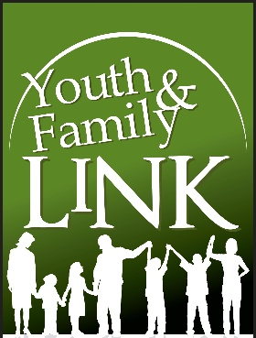
Teen Tuesday Registration
Tuesdays 6 – 8 PM
Ages 12-18

Parent Name (First, Last) :_________________________

Phone # :_______________________________________

Address :_______________________________________

E-mail :________________________________________

Youth Name :__________________________

Date of Birth :__________________________

Race/Ethnicity :_________________________

School Attending :_______________________
Please read, and sign below acknowledging the following :
Youth and Family Link does not provide Medical or Accident Insurance Coverage, and is not responsible for personal items that are lost or stolen.
Assumption of Risk, Waiver, & Release :
I am fully aware that there are special dangers and risks inherent to this activity, including but not limited to : the risk of serious physical injury or death, or other harmful consequences that may arise or result directly or indirectly from my participation in this activity. Being fully informed as to these risks and in consideration of my being allowed to participate in Youth & Family Link sponsored activities, I hereby assume all risk of injury, damage, liability, and harm to myself and my child arising from such activities. I also hereby individually and on behalf of my heirs, executors, and assigns, release and hold harmless Youth & Family Link, their officials, employees and agents, and waive any right of recovery that I might have to bring to claim or lawsuit against them for any personal injury, death, or other consequences occurring to me arising from my voluntary participation in this activity.

______________________________________________________________________________
Signature Date

